1 #include <stdio.h>

int main() {
int m, n, p;

// Fixed printf/scanf syntax
printf("Enter the dimensions (m, n, p) for matrix A (m*n) and B (n*p): ");
scanf("%d%d%d", &m, &n, &p);

// Declared 2D arrays correctly
int A[m][n], B[n][p], result[m][p];

printf("\nEnter the elements of matrix A (%d*%d):\n", m, n);
for(int i = 0; i < m; i++) {
for(int j = 0; j < n; j++) {
scanf("%d", &A[i][j]);
}
}

printf("\nEnter the elements of matrix B (%d*%d):\n", n, p);
for(int i = 0; i < n; i++) {
for(int j = 0; j < p; j++) {
scanf("%d", &B[i][j]);
}
}

// Corrected matrix multiplication loop
for(int i = 0; i < m; i++) {
for(int j = 0; j < p; j++) {
result[i][j] = 0;
for(int k = 0; k < n; k++) {
result[i][j] += A[i][k] * B[k][j];
}
}
}

// Printing the resulting matrix
printf("\nResulting matrix (%d*%d):\n", m, p);
for(int i = 0; i < m; i++) {
for(int j = 0; j < p; j++) {
printf("%d ", result[i][j]);
}
printf("\n");
}

return 0;
}</stdio.h

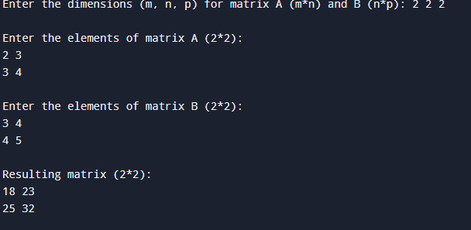
2 #include <stdio.h>

int main() {
char str[100];
int length = 0, i, isPalindrome = 1;

printf("Enter a string: ");
scanf("%s", str);

// Step 1: Manually find the length of the string
while (str[length] != '\0') {
length++;
}

// Step 2: Compare characters from both ends
for (i = 0; i < length / 2; i++) {
if (str[i] != str[length - i - 1]) {
isPalindrome = 0; // Not a palindrome
break;
}
}

// Output result
if (isPalindrome) {
printf("%s is a palindrome.\n", str);
} else {
printf("%s is not a palindrome.\n", str);
}

return 0;
}
</stdio.h>
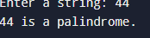
3 #include <stdio.h>
#include <ctype.h>

int main() {
FILE *fp;
char filename[100];
int ch;
int characters = 0, words = 0, lines = 0;
int inWord = 0;

printf("Enter filename: ");
scanf("%s", filename);

// Open file in read mode
fp = fopen(filename, "r");
if (fp == NULL) {
printf("Error: Could not open file %s\n", filename);
return 1;
}

// Read character by character until EOFyash \
yash

while ((ch = fgetc(fp)) != EOF) {
characters++;

// Count lines
if (ch == '\n') {
lines++;
}

// Count words using state flag
if (isspace(ch)) {
inWord = 0;
} else if (inWord == 0) {
inWord = 1;
words++;
}
}

// Handle edge case: last line without a newline character
if (characters > 0 && ch != '\n') {
lines++;
}

printf("\nFile Statistics:\n");
printf("Characters: %d\n", characters);
printf("Words: %d\n", words);
printf("Lines: %d\n", lines);

fclose(fp);
return 0;
}
</ctype.h></stdio.h>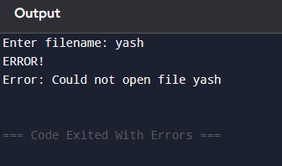
4 #include <stdio.h>

// 1. Define the student structure
struct Student {
char name[50];
int roll;
float marks;
};

int main() {
// 2. Declare an array of student structures for 5 students
struct Student s[5];
int i;

printf("Enter information for 5 students:\n");

// 3. Loop to store information
for (i = 0; i < 5; i++) {
printf("\nStudent %d\n", i + 1);
printf("Enter name: ");
scanf("%s", s[i].name);
printf("Enter roll number: ");
scanf("%d", &s[i].roll);
printf("Enter marks: ");
scanf("%f", &s[i].marks);
}

// 4. Loop to display information
printf("\nDisplaying Student Records:\n");
for (i = 0; i < 5; i++) {
printf("\nRoll: %d\n", s[i].roll);
printf("Name: %s\n", s[i].name);
printf("Marks: %.2f\n", s[i].marks);
}

return 0;
}</stdio.h>
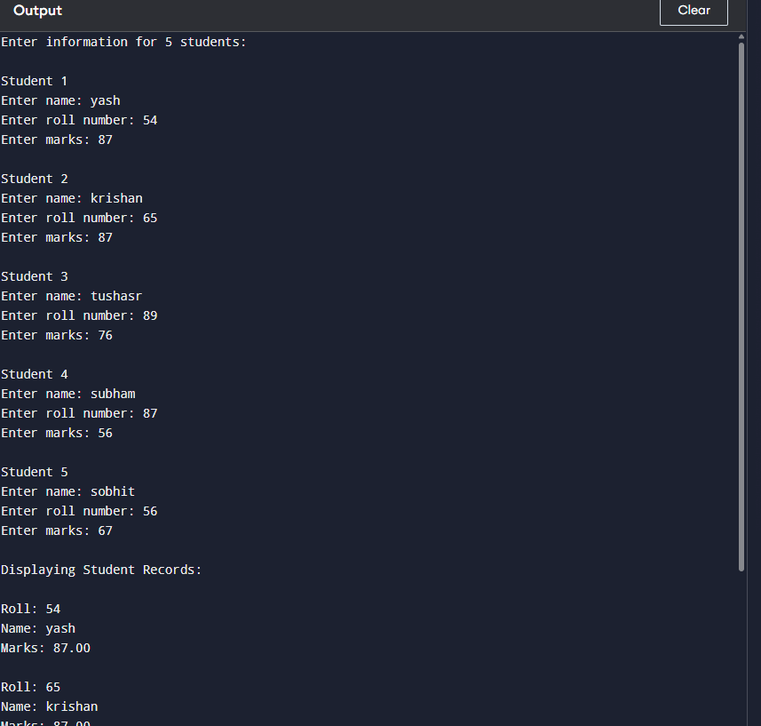
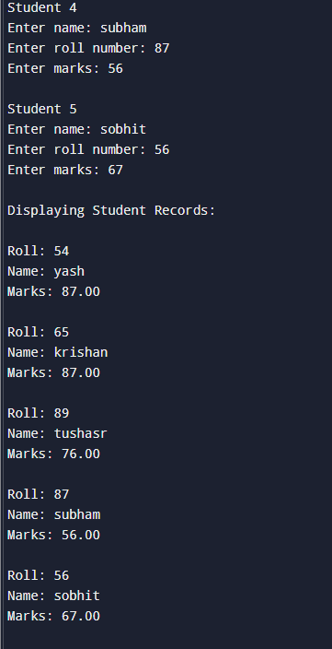
#include <stdio.h>

int main() {
int arr[] = {5, 15, 25, 35};
int n = sizeof(arr) / sizeof(arr[0]);
int sum = 0;
int *ptr = arr; // Base address

for (int i = 0; i < n; i++) {
sum += *(ptr + i); // Same as arr[i] but strictly uses pointer arithmetic
}

printf("Sum = %d\n", sum); // Output: Sum = 80
return 0;
}
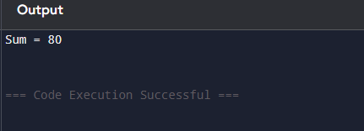</stdio.h>

